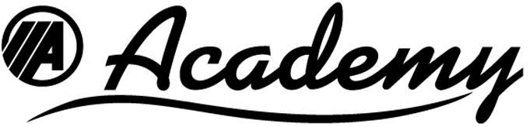
Coronavirus COVID-19 Vehicle Cleaning Procedure
- All Academy vehicles are to be thoroughly cleaned daily.
- In every vehicle, both the passenger and driver HIGH TOUCH areas must be disinfected
HIGH TOUCH areas are handrails/holds, arm rests, steering wheels, dashboards, lavatory surfaces, buttons, handles, switches, window rails, fareboxes, etc.
- The HIGH TOUCH areas must be cleaned of any visible dirt using a cleaning detergent
- The HIGH TOUCH area must then be thoroughly wiped with disinfectant
Our disinfectant to be used is: MICRO-CHEM PLUS Detergent Disinfectant Cleaner
- Micro-Chem Plus must be mixed with water according to the manufacturer’s directions: 2 ounces per gallon of water is effective against coronavirus.
- Restock the bus with sanitizer wipes, lavatory with sanitizer and extra toilet tissue.
- As a final step after the bus has been thoroughly cleaned and all staff are off the bus, one cleaning staff person will spray mist the interior of the bus starting at the back, including lavatory. The spray mist should be directed onto contact surfaces and the staff member should back down the aisle going from back to front spraying both sides of the vehicle.
- The vehicle may then be parked, and the surfaces permitted to air dry.
REMEMBER:
- All Academy cleaning staff should wear gloves when cleaning the vehicles.
- The spray cleaning staff will wear personal protective equipment (protective eyewear, respirator, gloves and protective coveralls) and must also wash hands when finished.
- Whenever gloves are removed hands must be thoroughly washed.
- Wet your hands with clean, running water (warm or cold), turn off the tap, and apply soap.
- Lather your hands by rubbing them together with the soap. Lather the backs of your hands, between your fingers, and under your nails.
- Scrub your hands for at least 20 seconds.
- Rinse your hands well under clean, running water.
- Dry your hands using a clean towel or air dry them
This process must be repeated daily until the COVID-19 outbreak has passed. Academy also encourages our employees to observe the CDC recommendations for prevention and treatment. This information is available at: https://www.cdc.gov/coronavirus/2019-ncov/about/prevention-treatment.html

